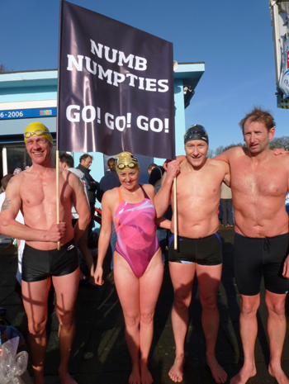Mock Album Review – replace the image on the right with the album cover

[ARTIST NAME]

[ALBUM TITLE]

CAM FM REVIEW

[Summarising statement]. *[Your Name]*

**TRACK LIST**

1. **We’re Jolly, don’t care**
2. **I’ve got matching underwear**
3. **Somewhere in the dark down deep**
4. **I heard monkeys never sleep**
5. **Have you ever written a book?**
6. **Don’t.**
7. **I can’t stand this**
8. **Neither can I**
9. **What am I talking about?**
10. **SHOUT LET IT ALL OUT**
11. **These are the things I could do without**
12. **COME ON**
13. **I’m talking to you**

A brief history of artist/band, genre?(50-100 words)

Idea’s for more reviewing:

-First impressions of album (whats changed, what hasn’t, what effect this has on the genre or artist/band history)

-When did there last album come out?

-IS IT GOOD OR BAD?!

-Talk about the songs you like/dislike.

-Favourite Songs

-Final thoughts

Cam FM Rating out of 5 (use the images below to show your rating)

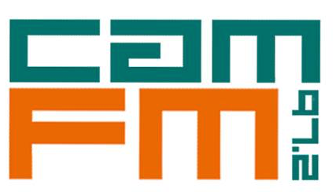

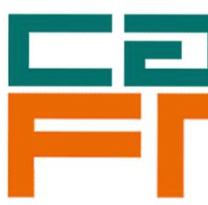

(Half just in case)

OUR RATING: /5

[The above template is just a guide. Feel free to format your review however you wish. This just gives you an idea of the content we would like you to include in the review.

The most important thing is to please export your review as a PDF document and send to our Head of Music Audrey: music@camfm.co.uk]